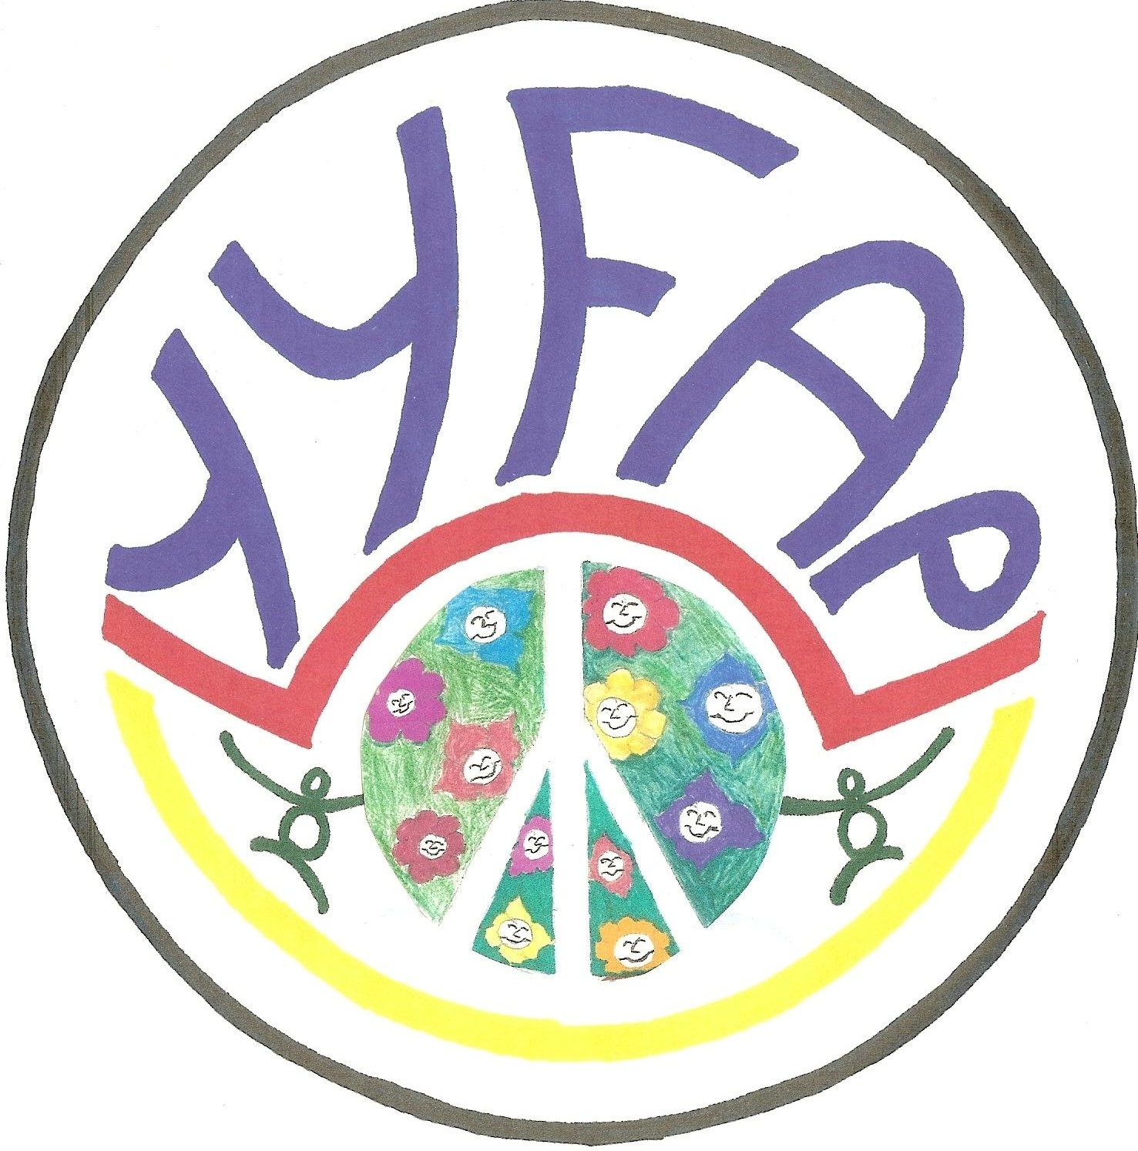


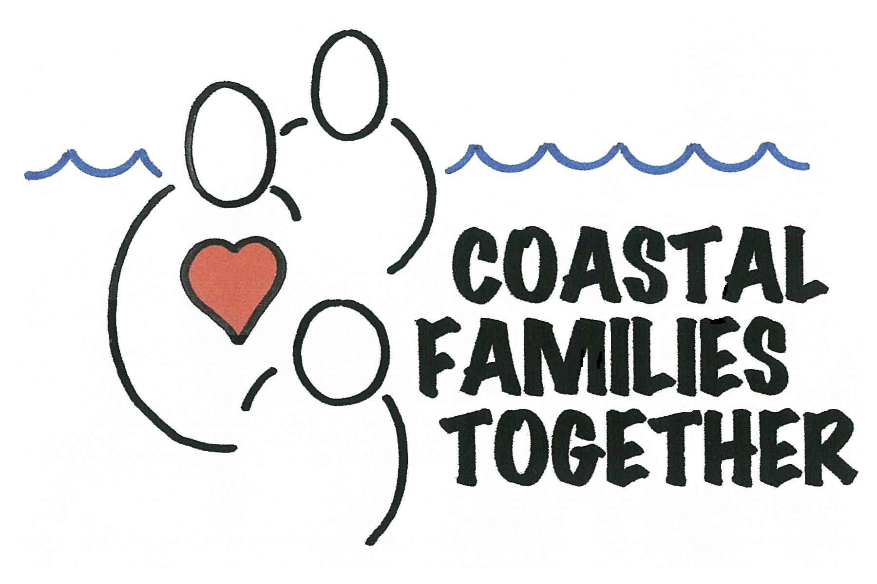
351 SE Harney, Newport OR 97365 * (541) 574-4485
email: cfthub@charter.net * Website: coastalfamiliestogether.com
Incredible Years Class
To register go to www.coastalfamiliestogether.com or call Coastal Families Together @ 541-574-4485.

For parents of children 5-10 years old

Being a parent is challenging! Gain a greater understanding of child development, effective discipline and embrace your role as a parent.
FREE
Nutritional Family Style Meal and
Childcare!
When: Tuesday Evenings
Starting April 24th for 10 sessions
Time: Dinner @ 6:00 p.m.
Class 6:30 p.m.—8:00 p.m.
Where: Yachats Commons Room 8
441 No. Highway 101
Yachats, OR 97498
Instructor: Judith Anderson & Alice Beck
Fee: $45 registration fee per family
Scholarships are available for all or part of the registration fee.
To register go to coastalfamiliestogether.com or call Coastal Families Together @ 541-574-4485

